Project Design Phase-II
Data Flow Diagram & User Stories

Date
Team ID | SWTID-2026-8907
Project Name | AI FAQ assistant
Maximum Marks | 4 marks

Data Flow Diagrams:
A Data Flow Diagram (DFD) is a traditional visual representation of the information flows within a system. A neat and clear DFD can depict the right amount of the system requirement graphically. It shows how data enters and leaves the system, what changes the information, and where data is stored

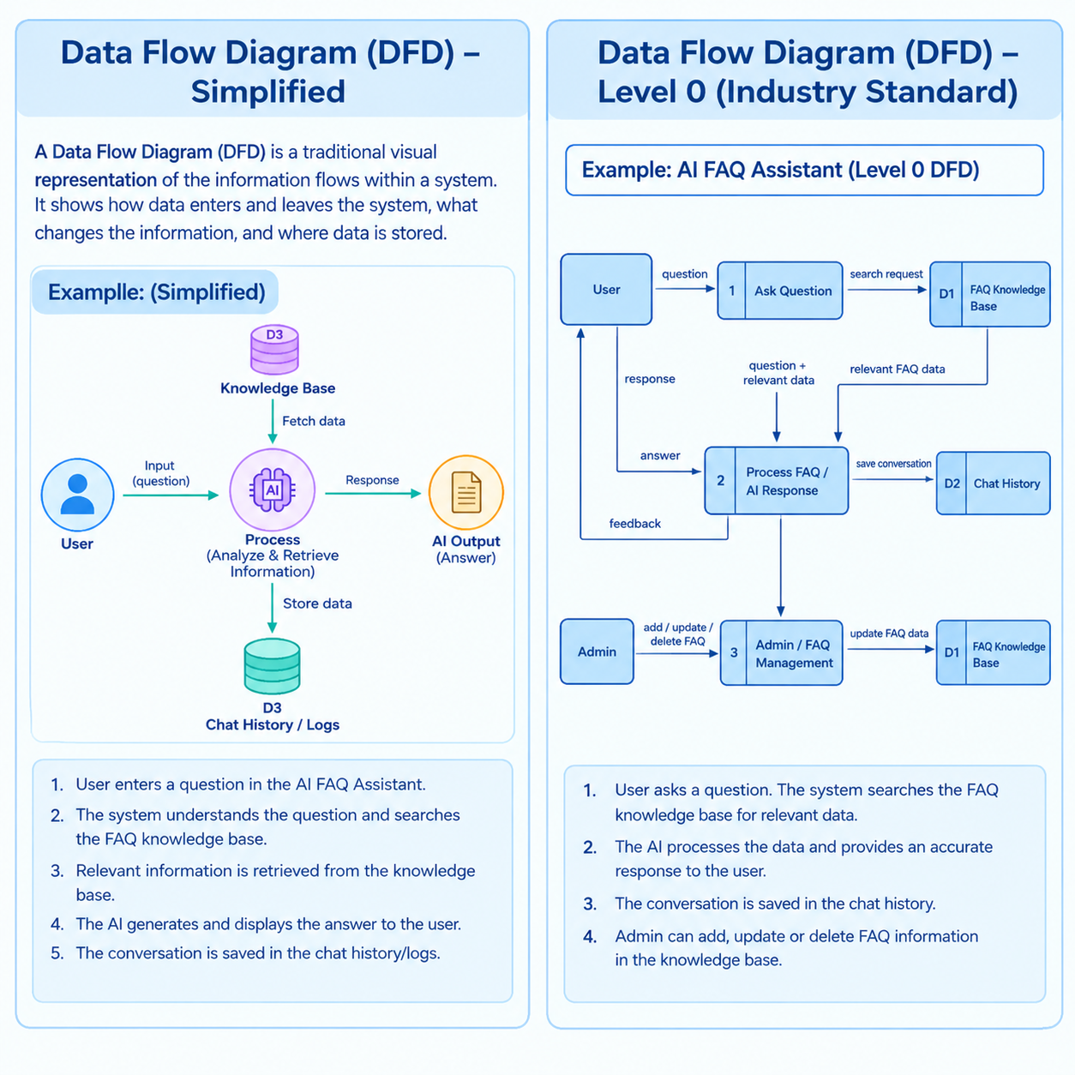

User Type | Functional Requirement (Epic) | User Story Number | User Story / Task | Acceptance criteria | Priority | Release
Customer (Mobile) | Registration | USN-1 | Register with email and password | Account created successfully | High | Sprint-1
 | Login | USN-2 | Login with email and password | Dashboard is displayed | High | Sprint-1
 | Ask Question | USN-3 | Ask a question to AI FAQ | Answer is displayed | High | Sprint-1
 | Dashboard | USN-4 | View FAQ dashboard | FAQ and chat are accessible | High | Sprint-1
Customer (Web) | Login | USN-5 | Login to AI FAQ Assistant | Dashboard is displayed | High | Sprint-1
 | Ask Question | USN-6 | Ask questions to AI | Question is submitted | High | Sprint-1
 | AI Response | USN-7 | Get AI answer | Relevant answer is shown | High | Sprint-1
 | FAQ Search | USN-8 | Search FAQs | Related FAQs are displayed | Medium | Sprint-2
Customer Care Executive | FAQ Management | USN-9 | Add new FAQs | FAQ is added | High | Sprint-2
 | FAQ Management | USN-10 | Update FAQs | FAQ is updated | High | Sprint-2
 | FAQ Management | USN-11 | Delete FAQs | FAQ is deleted | Medium | Sprint-2
Administrator | User Management | USN-12 | Manage users | Users can be managed | High | Sprint-3
 | FAQ Management | USN-13 | Manage FAQ information | FAQ is updated | High | Sprint-3
 | Knowledge Base | USN-14 | Update AI knowledge base | AI gets updated | High | Sprint-3
 | Dashboard | USN-15 | View system activity | Statistics are displayed | Medium | Sprint-3

